Year 11 History: Discrimination in the 1920’s USA

Source 1:
Bitter Fruit/Strange Fruit

Southern trees bear strange fruit,
Blood on the leaves and blood at the root,
Black bodies swinging in the southern breeze,
Strange fruit hanging from the poplar trees.
Pastoral scene of the gallant south,
The bulging eyes and the twisted mouth,
Scent of magnolias, sweet and fresh,
Then the sudden smell of burning flesh.
Here is fruit for the crows to pluck,
For the rain to gather, for the wind to suck,
For the sun to rot, for the trees to drop,
Here is a strange and bitter crop.

Source 2:
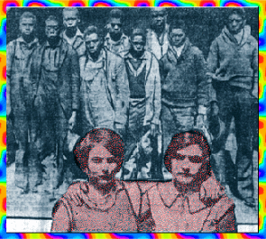

THE SCOTSBORO BOYS
The devastating day of March 25, 1931, started with hope for the young men on the freight train chugging away from their home town of Chattanooga, Tenn. For Eugene Williams, 13, the idea of leaving his birthplace and the grinding poverty there had seemed like a good and responsible one. "If I leave her, " he reportedly said of his mother, "it will mean one less mouth to feed." By the end of the day, Williams would become one of nine young black males forcibly taken off the train by a sheriff's gang and charged with raping two white girls.
By the next month, eight of the nine, including Williams, would be convicted and sentenced to death, beginning a long fight which threatened to rend the very fabric of American society apart.
Throughout the lengthy judicial proceedings, the AFRO-AMERICAN Newspapers kept track of the case -- interviewing participants, and even dispatching a series of telegrams during some of the most dramatic developments in the battle. The case would drag on for years and leave the lives of the nine decimated by the traumatic events.
The Scottsboro Boys (the young men were named after the Alabama town where they were tried for the first time) ranged in age from 13 to 21. They were: Roy Wright, 13, Eugene Williams, 13, Andy Wright, 17, Haywood Patterson, 17, Olin Montgomery, 17, Willie Roberson, 17, Ozzie Powell, 16, Charles Weems, 21 and Clarence Norris, 21. The nine, who were charged with attacking two white girls, one an admitted town prostitute, Ruby Bates and Victoria Price, immediately pleaded not guilty to the 20 indictments against them. Their pleas were swiftly rejected. An all-white jury in the court room of Judge E. A. Hawkins convicted eight of the boys, declaring a mistrial in the case of 13-year-old Roy Wright. This despite the publication of an expose revealing a frame-up by the communist Daily Worker newspaper just days after the arrest. Tried in three groups, the eight were sentenced to death on the same day - April 9, 1931.
The verdicts were hardly surprising in the climate of the time, where conviction was guaranteed of any black accused of such a crime. A local jurisprudence riddled with racism ensured that the defendants were at a disadvantage; the young men were assigned Milo Moody, a local lawyer, as a defense attorney who had no preparation in the case. According to a report in the April 18, 1931 edition of the AFRO by Managing Editor William N. Jones, who covered the story on location, some 10,000 white mountaineers and villagers came to town the day of the trial. Later that day -- April 6 -- a crowd assembled outside the courthouse and, surrounded by state troopers, reportedly staged a demonstration of approval, complete with a band playing "There'll be a hot time in the old town tonight."
The reaction to the convictions was swift and large scale. Just one day after the death sentences were handed down, the first big demonstration was held at St. Luke's Hall in Harlem. The next week, the International Labor Defense, a well-known communist group, who had entered the case immediately after the guilty verdict, joined with the parents of the boys to secure the services of General Geo W. Chamlee to represent them. The ILD would later clash with the National Association of Colored People (NAACP) over the representation of the youngsters.
From the very beginning, the boys' parents were passionate in the defense of their offspring. Mrs. Janie Patterson, mother of Haywood, spoke before a meeting of 1,000 workers the month her son was sentenced to die, while Ada Wright, mother of Roy and Andy, would be arrested and deported from Belgium after speaking to workers there about the young men.
The support for the boys overseas was dramatic. Demonstrations were held in Dresden, Leipzig and Berlin, Germany as soon as the verdicts came in. And, an international collection of intellectuals and scientists, including Albert Einstein, signed an petition demanding the release of the nine young men. Eventually, supporters would be joined by one of the alleged victims, Ruby Bates, who visited the Washington, D.C. office of the AFRO-AMERICAN Newspaper, where she denied that she had been raped by the young men.
Meanwhile, the petitions flied back and forth. Finally, on Nov. 8, 1932, Judge Hawkins set new trials for all nine boys for the March 1933 term of the Scottsboro court.
The second trial opened in Decatur, Ala. on March 28, 1933, following the filing of two defense motions for a change of venue and to quash the indictment against the boys on the grounds that there had been no blacks on the first jury. Despite this, a lily-white jury was picked to try Haywood Patterson, the first of the nine young men to be brought to trial. The town seethed with racial hatred as the proceedings began, with cries denouncing Bates and Lester Carter, a white boy who traveled with Bates and Price. Carter also confirmed that the rapes had never taken place. AFRO reporters on the scene flashed a series of telegrams back to their pubilsher Carl Murphy describing the tense scene.
Public appetite for news of the proceedings was unsatiable. AFRO reporters covering the trial delayed returning home to Baltimore, accepting invitations to report to supporters all over the area about what they had seen and heard about the case.
The trials would last for several years and eventually charges were dropped against five of the nine. The other four were retried and convicted; three were later paroled, and the fourth, Patterson, escaped.
But none would escape the scars of the experience.
A reporter visiting the young men five years after their original trials wrote of the toll that the horrific events had taken on them. Confined in the Jefferson County Jail, the reporter described the young men as "showing various ill effects of their five and one-half years of incarceration. The light in their eyes is no longer bright. The vim, vigor and vitality that characterized all nine at the time of their arrest has vanished," she wrote.
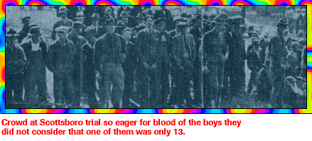
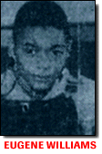
SOURCE 3: SOURCE 4:

My boy would have been in school today, but not having clothes even to go in, he went off to hunt work, and he was sentenced to die in the electric chair." This statement from Mrs. Mamie Williams of Chattanooga sums up the entire story of Eugene Williams, youngest of the nine Scottsboro boys. The sentence against Eugene was the first to be reversed. He was only 13 at the time of the Scottsboro trial, and the law of Alabama provides that persons under 16 must be tried in the juvenile court. But the law went unnoticed in the frenzy of Alabama's greatest lynch-holiday. Only after the International Labor Defense had fought, inside the court-room and out, against this illegal conviction, did the Alabama Supreme Court in 1932, reverse the sentence of death and remand Eugene Williams for a juvenile court hearing.
Family Poverty-Stricken
Among Chattanooga's poverty-stricken families, the Williams family was of the poorest. The father got only two days work a week; the house was gradually stripped even of its furniture. "My furniture man has got all my furniture except two beds and a table I made myself," Mrs Williams wrote in one of her first letters to the I.L.D. Without a chair or stove she cooked on the grate while it was cold, but now that it is so hot, and the grate is in the room where she and children sleep, she cooks out in the yard on bricks to keep from making a fire in the house.
SOURCE 5: SOURCE 6:
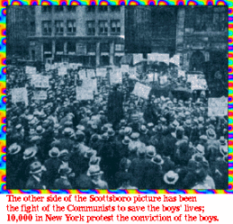
Telegram sent by Afro-American reporters (Young & Jones) to their office in
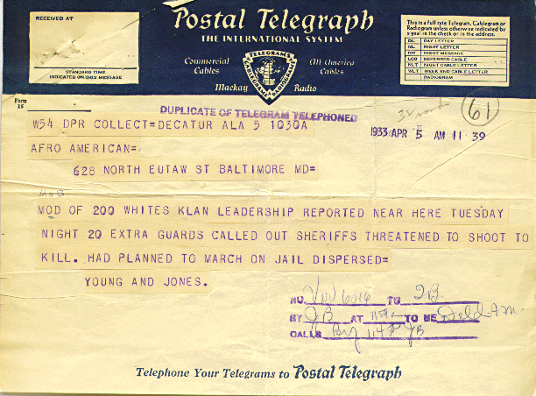
Baltimore. They were sent to cover the 2nd trial.

SOURCE 7: SOURCE 8:
Surprise telegram/ defence surprise witness
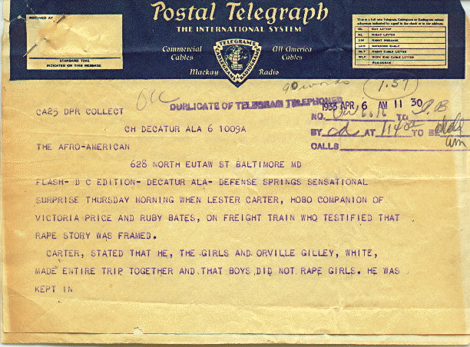
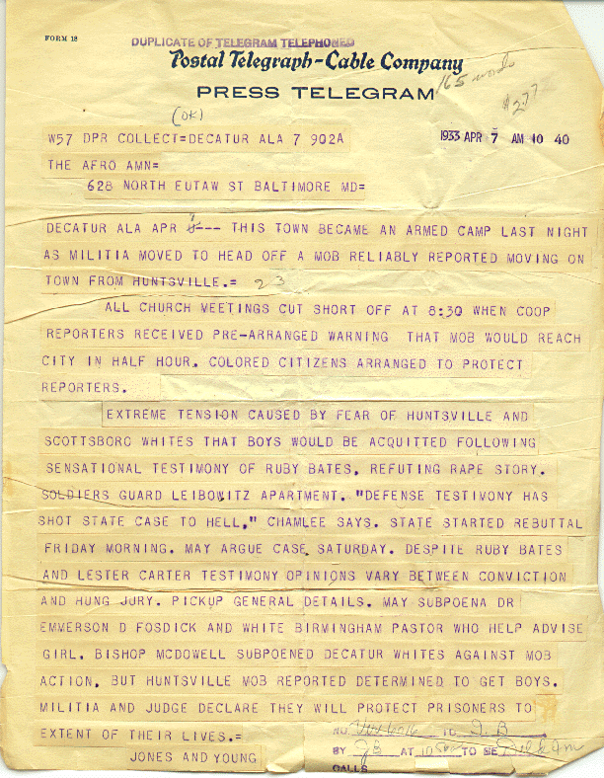

SOURCE 9:
